**Data structures and Algorithms**

**E-commerce Platform Search Function**

import java.util.ArrayList;

import java.util.List;

public class ProductSearch {

// Product List

private static List<String> products = new ArrayList<>();

// Initialize product database

static {

products.add("Laptop");

products.add("Smartphone");

products.add("Smartwatch");

products.add("Bluetooth Speaker");

products.add("LED Monitor");

products.add("Laptop Bag");

products.add("Keyboard");

}

// Search function using simple contains()

public static List<String> search(String keyword) {

List<String> results = new ArrayList<>();

for (String product : products) {

if (product.toLowerCase().contains(keyword.toLowerCase())) {

results.add(product);

}

}

return results;

}

public static void main(String[] args) {

String keyword = "laptop";

List<String> results = search(keyword);

System.out.println("Search Results for \"" + keyword + "\":");

for (String product : results) {

System.out.println("- " + product);

}

}

}

**OUTPUT:**

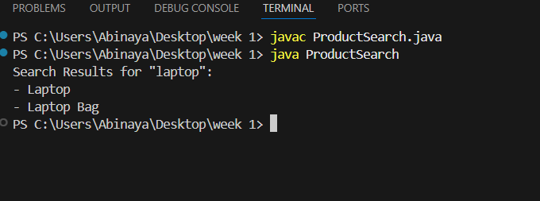

**Financial Forecasting**

import java.util.Scanner;

public class FinancialForecastingInput {

public static void main(String[] args) {

Scanner scanner = new Scanner(System.in);

// Ask how many months of data

System.out.print("Enter number of months: ");

int months = scanner.nextInt();

double[] revenue = new double[months];

double sum = 0;

// Get revenue input from user

for (int i = 0; i < months; i++) {

System.out.print("Enter revenue for month " + (i + 1) + ": ₹");

revenue[i] = scanner.nextDouble();

sum += revenue[i];

}

// Calculate average

double average = sum / months;

// Predict next month's revenue

System.out.println("Predicted revenue for next month: ₹" + average);

scanner.close();

}

}

**OUTPUT:**

